Alphabet Ping-Pong Game

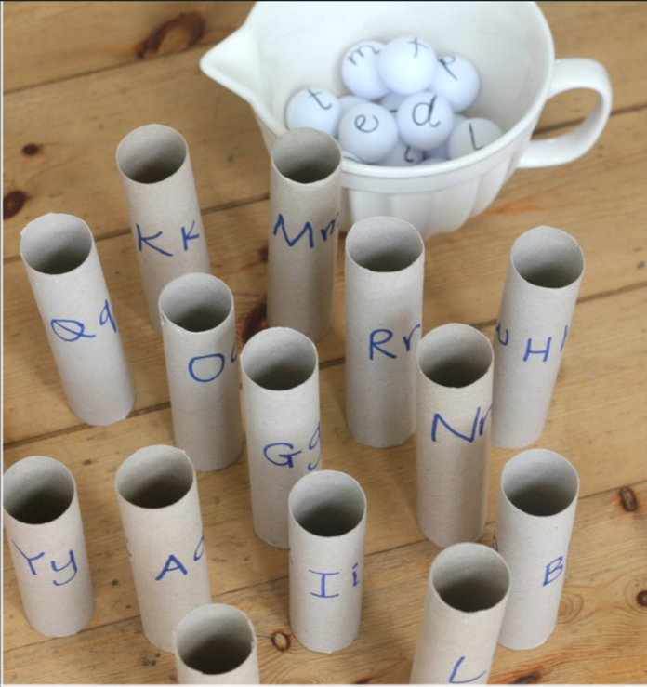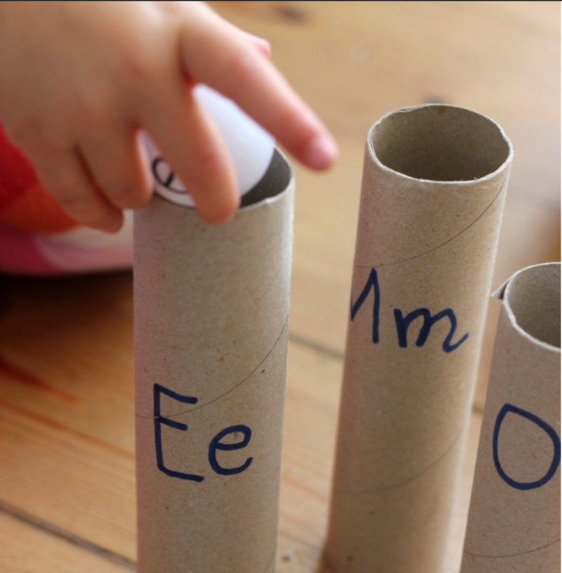

Purpose: to help kids learn their letters and alphabet in a way fun while developing their fine motor skills!

Supplies: 26 toilet paper rolls, sharpie, and 26 ping pong balls

Steps:
- Write letters on the toilet paper rolls
  - Can be upper or lower case or both
- Write letters on ping pong balls and collet them in a bowl
  - Can be upper or lower case or both
- Demonstrate how to match the letter and drop the corresponding ball to the roll
- During the activity observe the child for signs of frustration or feeling overwhelmed so that you can help them as needed.
- Provide encouragement and help the child have fun with this activity!

For more information go to: https://theimaginationtree.com/alphabet-ping-pong-literacy-game/

