This is what I look like when I am anxious or worried. Sometimes, I don’t know WHY I feel that way!
Here’s what I might be thinking:

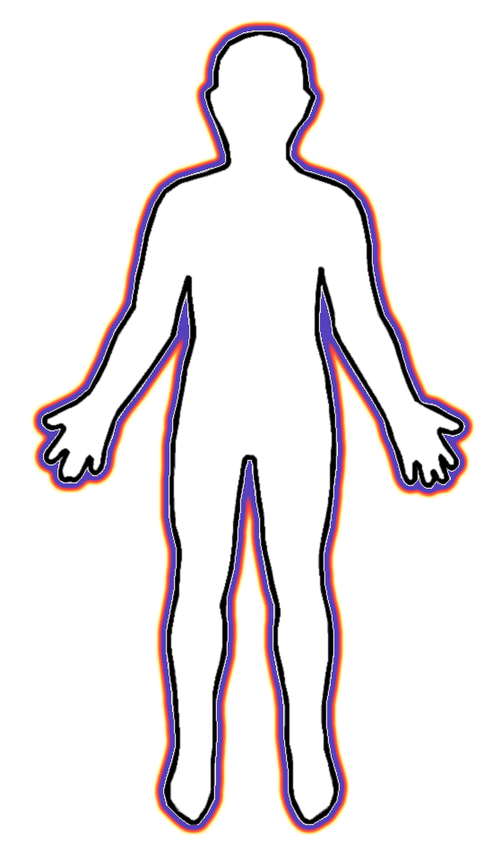
Here’s what I might be feeling inside my body.

