Paint Bag

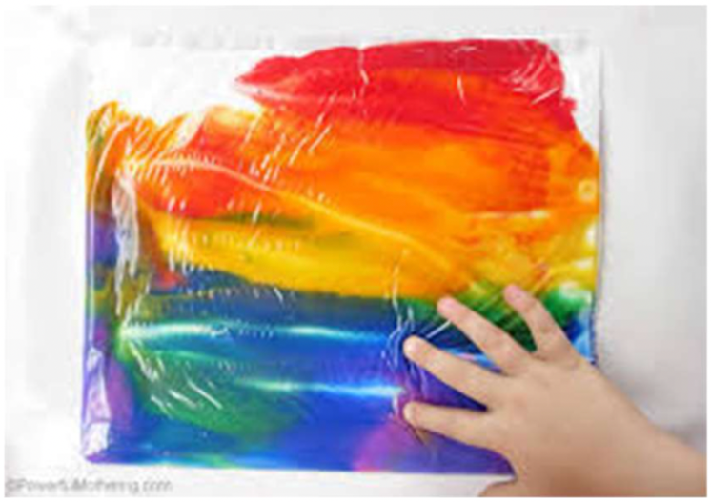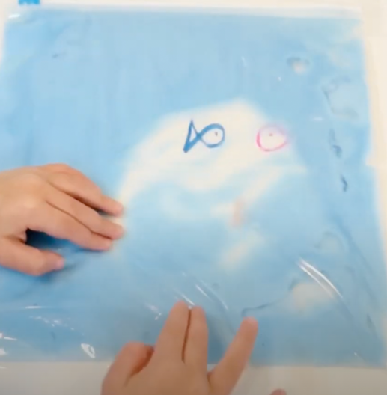

Purpose: to help kids their develop their fine motor skills and explore mixing colors in a fun mess-free way!

Supplies: clear zip lock bags, different paint colors

Steps:
- Place different paint colors in the zip lock bag and seal it
  - Make sure there is not an excess of air in the bag
  - Start with two colors and add more
- Encourage your child to mix the colors with their fingers
  - For an added challenge the child can “draw” shapes in the paint
- Add colors to the bag or use multiple bags
  - For an added challenge place a paper under the bag with spaced out numbers or drawings and the child will move the paint around to find them.
- Help the child have fun with this activity!

For more information go to: https://www.youtube.com/watch?v=QVtvcE8Xx-c

