Image of activity (materials used): 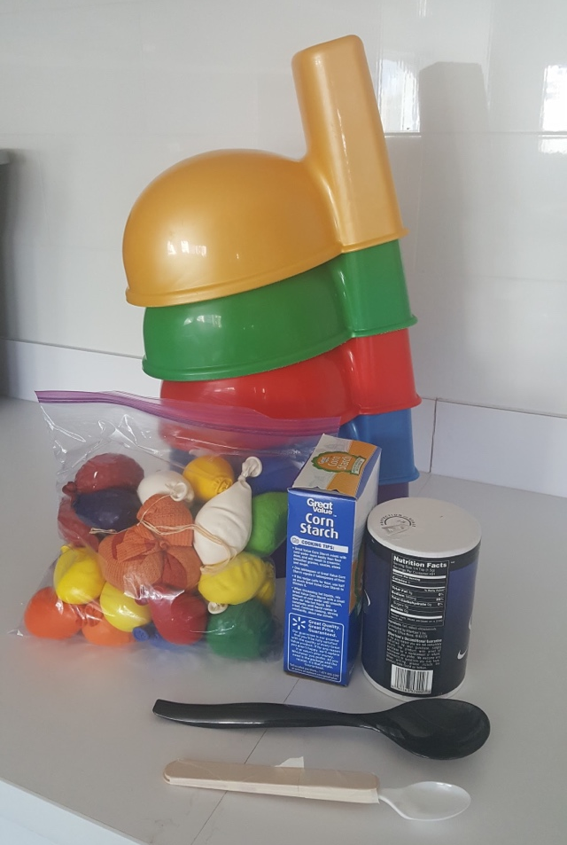
Supplies that are obtained and prepared in advance: Balloons, salt, baking soda, spoons of different sizes, spoons with bigger handles, funnel, cones for kids to race around, premade balloons with different materials (baking soda, salt, corn kernels, and rice), chopsticks for helping the salt down the funnel when filling up balloons, playground ball for an alternative activity, and stickers used for prizes.
Snacks were bought for this activity, as well as extra salt for making the balloons. This came at a cost of $11 total.
Options for grading the activity:
Sensory – different tactile stimulation with different materials used in balloons, be able to hold the spoon with the tape around the handle or just the plastic handle, being able to make their own balloon with different materials (holding the rubbery balloon, interacting with the salt and the funnel, feeling the variety of materials we have used in this activity)
Personal/Social –an impatient child could go first so they don’t disrupt other children, work as a team if participating in a relay race, handing off the balloon to the next child in line, do the race individually so they have less social interaction.
Motor –hold the egg with their hands if not able to hold a spoon, take one of the pre- made balloons instead of making one themselves, have someone do hand-over-hand to help them balance the balloon on the spoon.
Options for adapting the activity:
Sensory – If they have sensory issues with the balloons they can take one of the premade ones and have someone else put it on the spoon.
Personal/Social – be able to work as a team or individually to accomplish the goal of walking to a designated area and back with egg on the spoon: children who do not work well in a team may complete the activity individually. A child may follow the example of the OT student when completing the race instead of following verbal instructions; this would be adapting based on the child’s social cognitive abilities.
Motor – If a child is in a wheelchair, we can move the boxes to make them farther apart and easier to navigate or allow them to just go back to the end of the boxes and come back. With a child with visual impairments, we can hold their hand and lead them through or talk with them and have them follow the sound of our voice to the end and back. If a child is not able to grasp the spoon handle, they can use the large handled spoons.
Illustrating the activity if needed: picture included above
Model for the activity if needed:
1. Students will set out spoons with a variety of handles and sizes. They will set out cones about five feet apart and make sure the cones will not tip over if the wind picks up.
2. When children come outside, students will help the children choose a spoon and a filled balloon (children can choose a balloon based on the color they like or the material inside the balloon). If a child does not wish to use a spoon, allow them to hold the balloon in their hands and complete the activity. Students may also place the balloon on a child’s spoon if they do not want to touch the balloon.
3. There will be materials to fill up a balloon with salt if a child wishes to make their own balloon and take it home with them afterward. Funnels, salt, and balloons will be used to make the sensory balloons with children.
4. Volunteers will have children line up behind the first cone and take turns going around the cones and coming back while balancing their balloon on the spoon. Children may be directed to serpentine (weave in and out) through the cones or just walk in a straight line to the end and back, depending on their ability.
5. Children may race if there are enough of them by having two go at the same time and walking/running to the last cone and back while balancing the balloon on their spoon.
6. After children have completed the activity they may receive a sticker or they may take their balloon (to be used as a stress ball or for sensory stimulation).
Additional (back-up) games/activities:
- Sorting balloons by colors or textures
- Tossing the balloons back and forth (catch game)
- Making the balloon for a stress ball, using the materials the students brought with them to Mosaic (salt)
- Bring ball to play kickball or catch outside

