Sensory Writing Tray

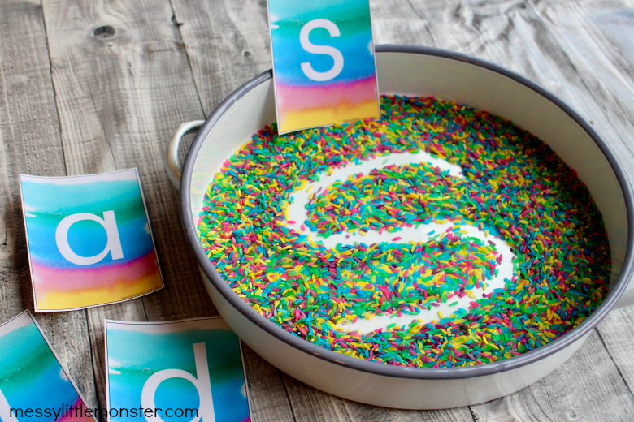

Purpose: to help kids write their letters and alphabet in a way fun away while experiencing different sensations.

Supplies:
- letter or number cards
- rice or beads or shaving cream
- shallow tray or bowl
- paintbrush (optional)

Steps:
- Set up your sensory writing tray by filling a tray with a thin layer of rice.
  - Make sure you don't add too much, you want to see the bottom of the tray when you draw in the rice.
- Using a finger or a paintbrush write a letter in the rice.
  - The colour from the bottom of the tray shows through so you can see the letter you have written (a white tray works well).
- After each letter or number shake the tray to reset the rainbow rice and off you go again!

For more information go to: https://www.messylittlemonster.com/2020/04/sensory-writing-tray-for-handwriting-practice.html

