Shaving Cream Sensory Bin

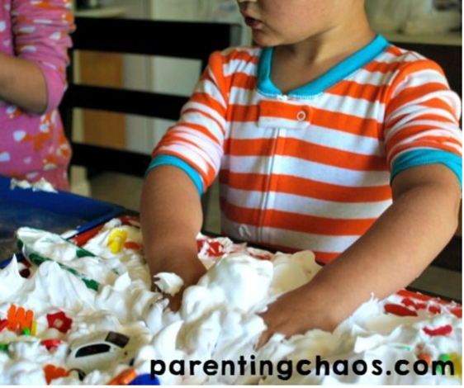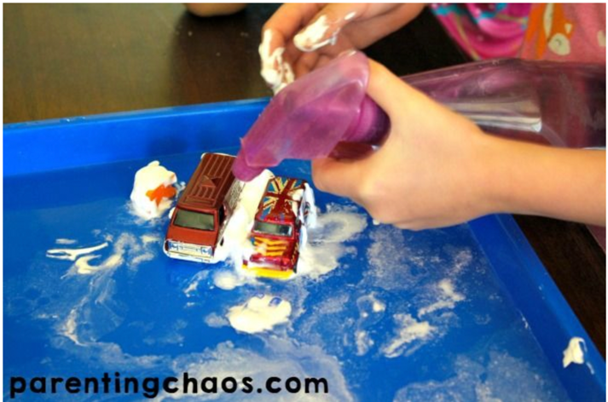

Purpose: Sensory Bins are a fabulous tool for learning. They are a quick and easy way to get children engaged while exploring a variety of different skills and concepts.

Supplies: Shaving Cream, toys, trays or bins, plastic letters or numbers

Steps:
- Simply grab your two trays or bins and cover one with shaving cream.
- In the other tray pour a very tiny amount of water
  - (you do not want to over do it as kids will also be spraying water into this tray).
- Then fill your spray bottle with water
- Dump the toys into the tray with the shaving cream.
- Let the kids play with the cream and try to get out their toys
  - They can have a “car wash” with the spray bottle in the other tray.

For more information go to: https://parentingchaos.com/alphabet-car-wash-sensory-bin/

