Sort and Count Bottles

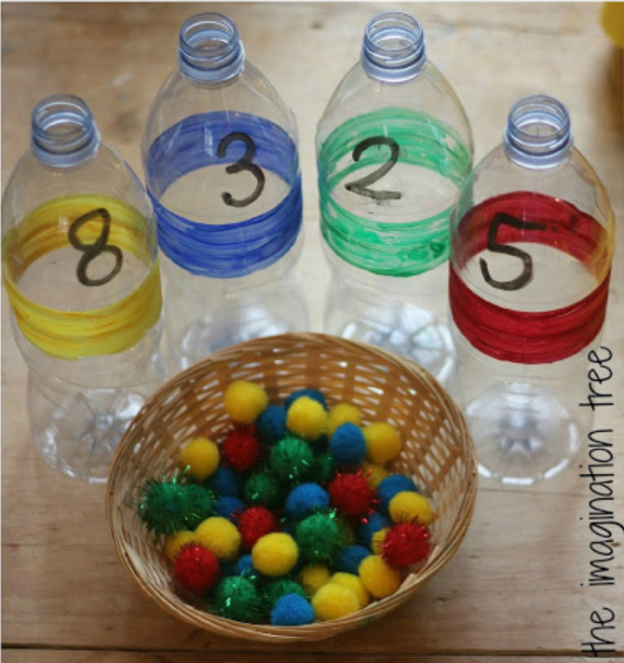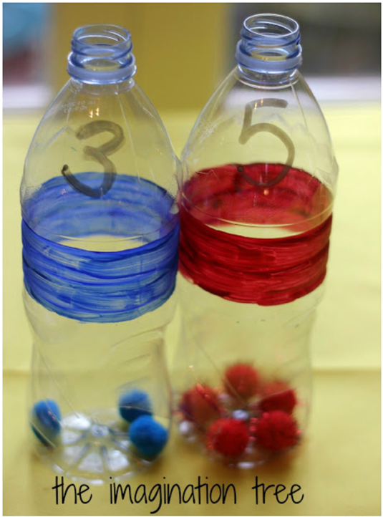

Purpose: to help kids learn their colors and numbers in a way fun while developing their fine motor skills!

Supplies: Empty water bottles with the label removed, different colored sharpies and different colored pom poms (that will fit inside the bottle)

Steps:
- Number and color the empty water bottles
  - can be cups if this is too challenging
- Collect corresponding colored pom poms and put in a bowl
  - adjust the number and size of pom poms in the bowl to appropriately challenge the child
- During the activity observe the child for signs of frustration or feeling overwhelmed so that you can help them as needed.
- Provide encouragement and help the child have fun with this activity!

For more information go to: https://theimaginationtree.com/sort-and-count-maths-bottles/

