Tape Road

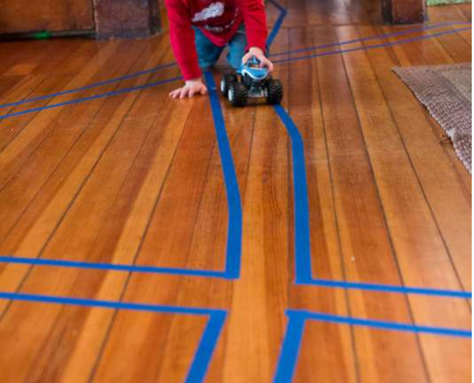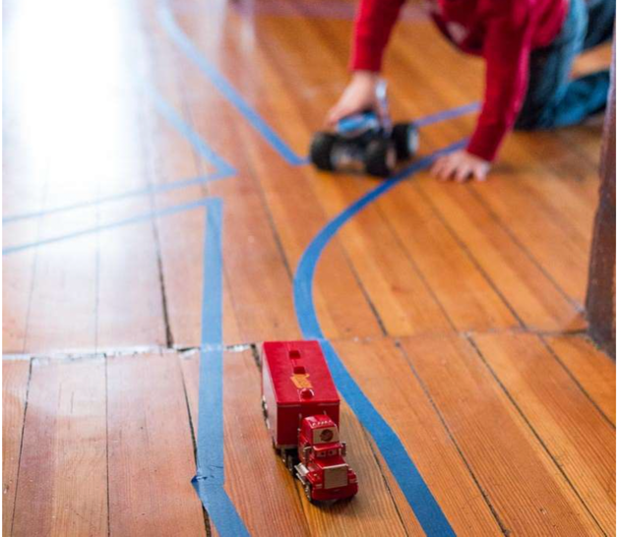

Purpose: to help kids their develop their fine motor skills by grasping a toy car and their gross motor skills by crawling throughout the house!

Supplies: a clean / clutter-free / carpet-free floor, painters’ tape, toy car

Steps:
- Make a tape road with your child’s input and help
  - Their wider the road is the easier it will be
  - the narrower the more difficult
- collet toy cars
  - The bigger the car the easier it will be for the child to grasp it
  - The smaller it is the more difficult
- Demonstrate the rules of the game are to stay within the lines of the “road”
- Help develop a “story” with your child. Such as driving a firetruck or having a race
- During the activity observe the child for signs of frustration or feeling overwhelmed so that you can help them as needed.
- Provide encouragement and help the child have fun with this activity!

For more information go to: https://handsonaswegrow.com/tape-road-simple-activity/

